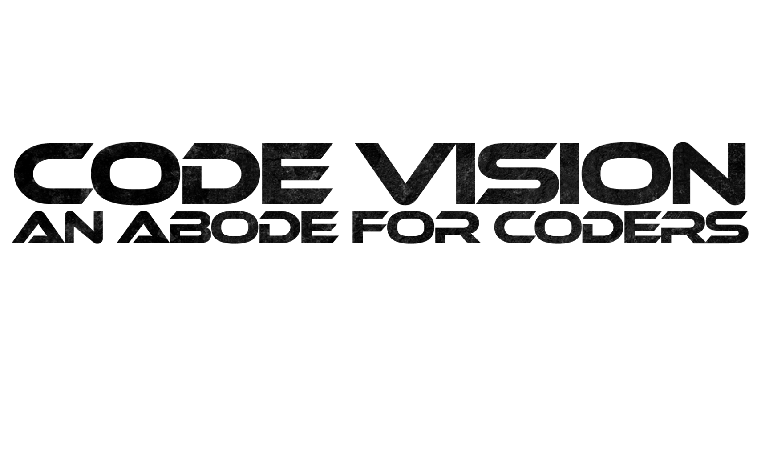–––––––



To,

The Head of Department, CSE,

(President Code Vision),

Bengal College of Engineering and Technology,

Durgapur

Date:

Subject:

Sir,

Sincerely,

Code Vision Club

(Mr. Prasenjit Maji,

Convener Code Vision)

(Mr. S.K. Abdul Rahim,

President Code Vision)